Computer Games for Dubbing Teaching: The "dublor sho" Game

Yasaman Saffari

Faculty of Multimedia

Tabriz Islamic Art University

Tabriz, Iran

y.saffari@tabriziau.ac.ir

Leila Doubakhti

Faculty of Multimedia

Tabriz Islamic Art University

Tabriz, Iran

l.dobakhti@tabriziau.ac.ir

Abbas Ghaffari*

Faculty of Architecture and Urbanism

Tabriz Islamic Art University

Tabriz, Iran

ghaffari@tabriziau.ac.ir

Behnam Alizadeh Ashrafi

Faculty of Multimedia

Tabriz Islamic Art University

Tabriz, Iran

b.alizadehashrafi@tabriziau.ac.ir

*Abstract*— One of the important multimedia fields is the art of dubbing. In the art of dubbing, human and non-human sounds are used. The focus of this study is on the human voice in the form of speech. Speech sound consists of a series of acoustic features. By changing the acoustic properties of sound through laryngeal exercises, more specific sounds can be achieved. Dubbing artists generally have unique sounds that can be achieved with practice. In this study, by extracting the acoustic features of famous dubbers sound and training a neural network, we extracted the sound pattern of dubbers. Then, based on this model a simple computer game called "Dublor Sho" was made to practice sound. Finally, four participants were asked to rate the game to evaluate the game and their sound progress was assessed before and after the game.

Keywords—dubbing, educational game, acoustic, python, neural network.

# Introduction

Speech can have a profound effect on the thoughts and feelings of the audience. Many elements, such as the tone of the sentences and the physical characteristics of the sound, can create a sense of vitality and a closer connection between the audience and the speech. Many specialists in the field of speech psychology and sound physics work to achieve patterns of increased impact on audiences in a variety of areas, including education, nursing and singing. Many intelligent systems have been designed in the field of human speech sound, including voice recognition, text-to-speech and vice versa. Voice is a fundamental process in human relationships, in communicating, in transmitting the message through speech, and in transmitting emotions. Acoustic sound analysis includes several parameters:

* Average Fundamental Frequency (F0), which indicates normal pitch, and pitch pressure (SPL = Sound Pressure), which indicates loudness level.
* Frequency perturbation and amplitude perturbation Frequency (Jitter) and Shimmer Amplitude and Harmony to Noise Ratio (N / H) to assess sound quality.

One of the important areas of multimedia is the art of dubbing. In this area, artists work with special and influential voices. Dubbing a movie or animation uses different human and nonhuman sounds. In this study, we only deal with human speech in a non-humorous way. In this research, we first introduce the sound characteristics of a serious artistic dubber. Then, analyze the acoustic sound of 49 male dubbers and 9 female dubbers by CNN model and obtain an average of the features that characterize a sound as a dubber. To classify the audio clips, 4 features extracted, Mel-Frequency Cepstral Coefficients, Spectral Centroid, Zero Crossing Rate, and Spectral Roll-off. All the features are then appended into a .csv file so that classification algorithms can be used. Once the features have been extracted, existing classification algorithms are used to classify the audios into different genres.

Finally, based on the results, we design and implement a dubbing sound exercise computer game called "Dublor Sho". In the next stage, by evaluating this software by testing on some students with normal voice before and after playing the game for 3 round, and measuring the similarity of their voice to the sound pattern of the dubbers pattern, the performance of the system designed to practice sound in dubbing is measured.

# Ease of Use

## Voice Analyse

Each person's voice is unique. There are signs of a mood in the sound and soul of the speech, and it is like the appearance of one's personality, such as low self-esteem or with self-doubt. The shy person has a quiet voice, while mastering the tone of voice and clarity of speech are the hallmarks of confident people. Emotions affect our voice, and sometimes even so intensely that they choke the throat. During stress, one's respiratory pattern changes. When the muscles contract and stretch, the maximum capacity of the lungs cannot be used. The following are three key elements in making a sound that are essential for anyone who wants to be an effective speaker:

* Loudness: To be heard
* Transparency: To be understood
* Variety: To create interest

Other elements such as speed and pitch, tone, emphasis, and pause can also affect how effective the speaker is.

In any case, speech has an impact on the target brain that can convey a message or arouse emotions. Speech involves the structure of time the brain must analyze in order to perform linguistic processing. To study the neural basis of this analysis, acoustic signals, stimuli made by different parts of natural sound, are used. Duration almost excludes stimuli by retaining their properties, while stimuli interfere with longer scales. Using variable lengths of each sound frame, samples of external speech sound were produced to eliminate language cues which altered the amount of natural acoustic structure. The results indicate that peech analysis in the human auditory cortex is distinct from lexical, semantic, or syntactic processes [1].

An exploratory study to investigate the relationship between examiner quality and child performance in the digital version of the language comprehension test and grammar acceptance test in two Cognitive Performance Indicators was conducted. Participants (n = 86) were 8-year-old children with normal language comprehension skills. Two groups of children were trained through the recording of a female speaker: one was taught with ordinary voice and the other with simulated voice. The findings suggested that simulated sound could enable the child to be able to process the sound signal processing by understanding the sound [2].

In another study, the audio characteristics of the voice recordings of the singing test were assessed before and after 30 minutes of absolute rest in female chorus singers. A total of 13 experienced blind soprano readers were evaluated through time-lapse audio parameter analysis. The underlying frequency increased after 60 minutes of singing and remained after 30 minutes of rest and cooling, proving to be an efficient parameter for detecting intrinsic changes in sound when singing. Also, in order to investigate the effect of voice quality deficits on speech-language processing by children, empirically, 107 children aged 3 years were divided into three groups, each listening to a single audio text and then undergoing a six-question test. One in a controlled voice, one in a mildly inhaled sound, and the other in a loud decibel sound. The results showed that children's perceptions of speech differed in the three sound qualities, regardless of gender and IQ. Performance in control passes was better than performance in mild and severe disconic sounds [3].

The relationship between psychological factors and acoustic characteristics was investigated in another empirical study. It was conducted quantitatively using SAS (version 9.2) to investigate the relationship between acoustic variables, attachment, trauma, and self-efficacy. LingWaves was used for voice analysis. Continuity and history of trauma as well as a sense of shame affect sound quality and voice control. The results addressed the need for a greater relationship between the psychological factors associated with early emotional development and the vocal characteristics of professionals [4].

Based on the study of the related literature the field of work and technologies that are used can be categorized as follow:

### In terms of the selected data, the most common data were:

1. Two-channel speech sound recording to produce about 6,000 words for text-to-speech system [5].
2. Capturing the cepstral coefficients of audio data with a frame size of 50 milliseconds sengupta [6].
3. Using 10 speakers, half female and half male, each presented 10 one-and-a-half minute standard sentences by TTS software and stored in .wav format [6].
4. Google's North American English and Mandarin Chinese TTS systems [7].
5. TIMIT [7].
6. LibriSpeech which contains 16 kHz sounds for 2484 speakers [8].
7. The VCTK dataset contains 108 English speakers of various accents [8].
8. 90 natural Persian adults of Zahedan (45 males and 45 females) [9].

### In terms of voice recording devices:

1. Record laryngeal canal from laryngograph device with sensor necklace [5].
2. Speech voice recording from the Sony Dynamic Cardiode Microphone [5]

### In terms of diagnosis:

1. Accent detection: Parallel clusters in two ways: averaging and weighting [10].
2. Emotion recognition: PCA principal component analysis, focal correlation analysis (CCA), Best First search methods, correlation-based analysis, genetic algorithms, vector machine support [11].
3. Speech Recognition: Neural Network Algorithms and ASR Encryption [11].

### In terms of extract feature

1. Spectral Central Domain - Its Inferior Derivative Zak Conversion to Speech Signal - Mel Coefficients - Capstrom and its Derivatives [12].
2. To extract the melting coefficients from the Tolubax MIR or Music Information Retrieval [10].
3. The output models extract the basic logarithmic frequency values ​​and the phonemic period from the linguistic features trained for each language.[7].
4. Voice of the singer, which includes multiple pitch, tempo, pitch, vibration [13].
5. Prescription to examine the relationship between acoustic variables, attachment, trauma, and self-efficacy [4].
6. lingWaves [4].

### In terms of model training

1. Multi-speaker models with 800,000 samples have been trained with the initial learning threshold of 3 * 10 * 4 [14].

### In terms of assessment

1. Auditory testing required to identify the prototype versus the artificial [14].
2. WaveNet evaluation on TTS was performed by comparing thematic pairs and MOS [7].
3. Kruskal-Wallis, Student t and Mann-Whitney tests [9].

## Educational Games

In many cases, the application of serious games and simulations for learning purposes provides an opportunity for learners to apply acquired knowledge and to experiment and get feedback in form of consequences, thus getting experiences in a “safe virtual world” [15].

Some apps are focusing on the skills required to make music, such as singing or playing an instrument (e.g. StarMaker) “Fig. 1”. These apps mostly make a live audio analysis of the user’s voice or the sound of the instrument played, and match this to the original music score via for instance an XML file [16].

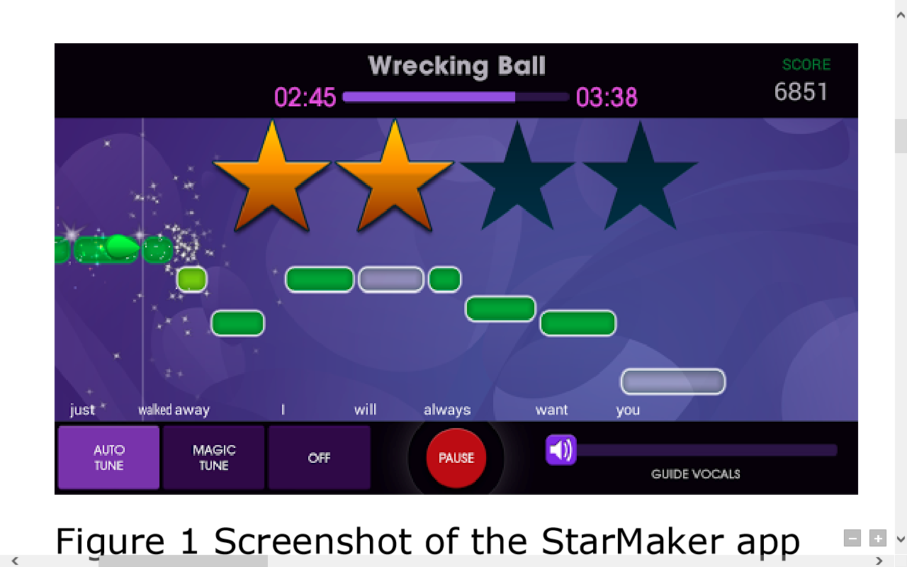

Fig. 1. Screen shot of the StarMaker app [16].

Some other games are music games, such as Piano Dust Buster 2 “Fig. 2”, that are based on repeating a melody in a game-like environment, without making use of an external audio source [16].

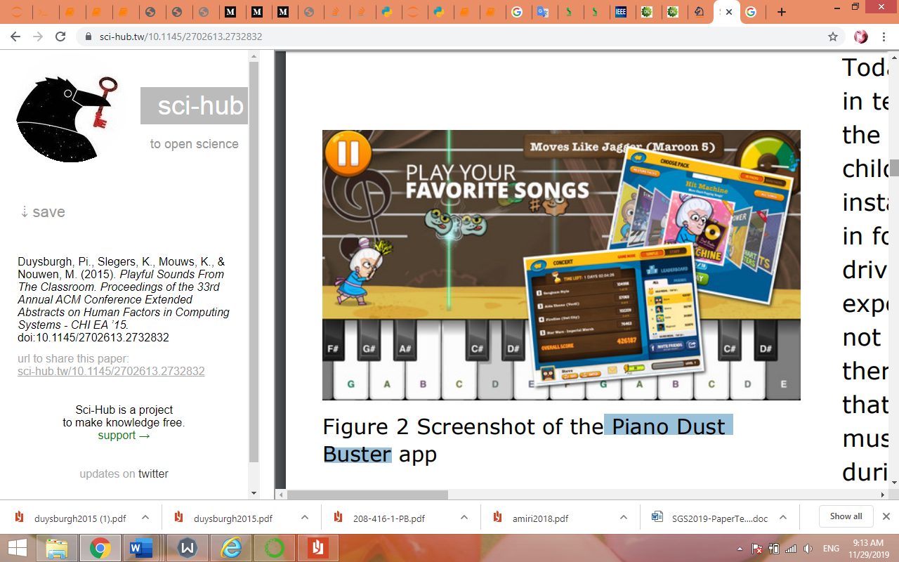

Fig. 2. Screenshot of the Piano Dust Buster app [16].

A research presented a framework for design of effective educational games for Deaf children based on Children Teaching Methodology and Educational Digital Games literature. The results included: the application of the framework in creating a web authoring tool that allows non-experts in game design, such as Deaf children teachers, to create educational games in a simple and semi-automatic way; and an example game generated by the tool. Also, they present that the support structures of the proposed CFW are four: Gameplay and Tutoring, Teaching-Learning, Student or Player, and Graphics and Interface. Each module in the Conceptual Framework has a key-role in the production of an educational game for Deaf children. The modules have specific responsibilities regarding the game, but all modules interact with each other, since the features of a game, even with its peculiarities, are interconnected. “Fig. 2” displays the four modules and their interconnections [17].

Fig. 3. Conceptual Framework for Educational Games Design [17].

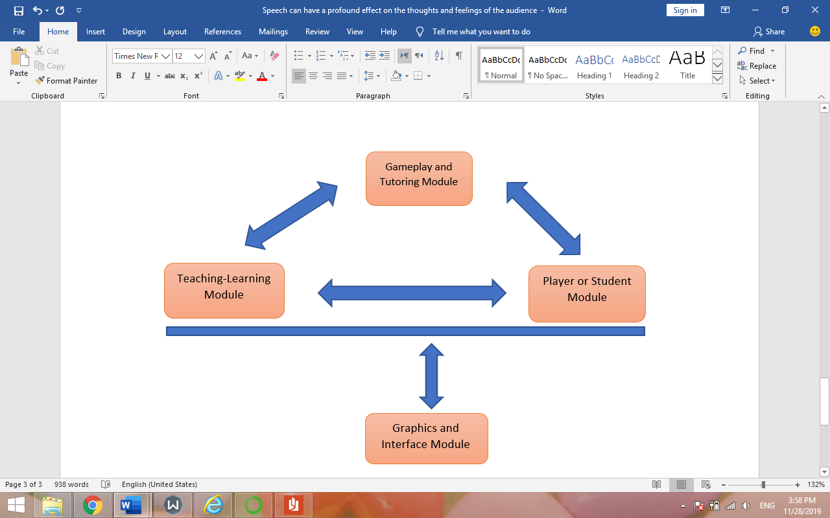

A music training and entertainment system allows a user to input a selection of source music in a native format, and isolates a desired vocal or instrument component within the source music. The user selects the component of the source music against which to be compared. The system suppresses the non-selected components of the source content to isolate the user-selected component. The system receives user input corresponding to the isolated component, and matches the user's performance to the original performance on the basis of pitch, rhythm, and quality comparisons. In a graphical user interface, avatars representing the user and judges are displayed in relation to an audience. Audience reaction is configured to reflect a score obtained by the user. A lyric extraction and generation process displays lyrics to a song in real time to the user as the music track is played [18].

## Sound Classifation

Extraction of acoustical features from digital music recordings has been used for various audio classification applications such as genre or music similarity. Likewise, emotion classification schemes are based on audio signal analysis parameters. There are many studies which indicate the significance of acoustic and musical features to emotion in music [19].

According to the non-stationary and non-linear characteristics of poultry voice and the situation that it`s hard to obtain enough sound samples, a poultry voice classification method based on Empirical Mode Decomposition (EMD), Teager energy transformation, and Support Vector Machine (SVM) is proposed. Firstly, the poultry voice signals are decomposed into a finite number of intrinsic mode function (IMF). Then, the Teager energy of five IMFs filtered are used to form characteristic vectors. Finally, the eigenvectors are put into a support vector machine classifier. The results of animal voice signals experimental recognition showed that this method had high accuracy and good generalization abilities even in the case of small number of samples. The approach proposed could identify the poultry voice effectively [20].

Convolutional Neural Networks (CNNs) have proven very effective in image classification and show promise for audio. The various CNN architectures to classify the soundtracks of a dataset of 70M training videos (5.24 million hours) with 30,871 video-level labels are used. At a research, examined fully connected Deep Neural Networks (DNNs), AlexNet [1], VGG [2], Inception [3], and ResNet [4]. It investigates varying the size of both training set and label vocabulary, finding that analogs of the CNNs used in image classification do well on audio classification task, and larger training and label sets help up to a point. A model using embeddings from these classifiers does much better than raw features on the Audio Set Acoustic Event Detection (AED) classification task [21].

# Game Design

In order to investigate the impact of computer games on sound art education and to improve sound in dubbing voice, we designed and implemented a simple game. The main focus was on the classification of dubbers sound based on the extraction of acoustic characteristics. In this game, no attention was paid to graphics and it was an adult game. The purpose of the game was purely educational and had no entertainment aspect. This game had no user interface and was designed for research purposes only.

## Implementation Architecture

The architectural diagram of the "dublor sho" game is illustrated in figures 4 & 5.

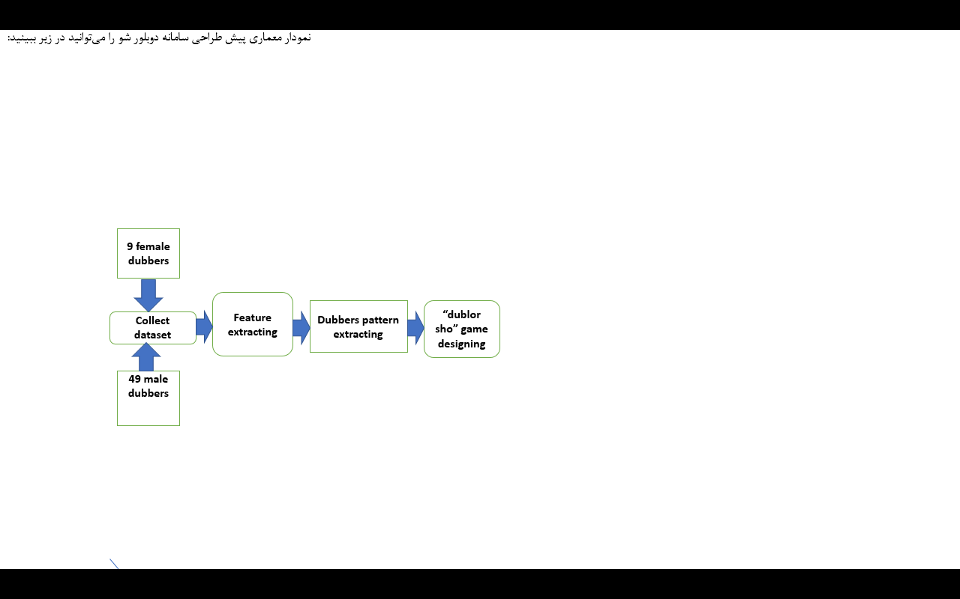

Fig. 4. The Pre-designed architectural diagram of the "dublor sho" game

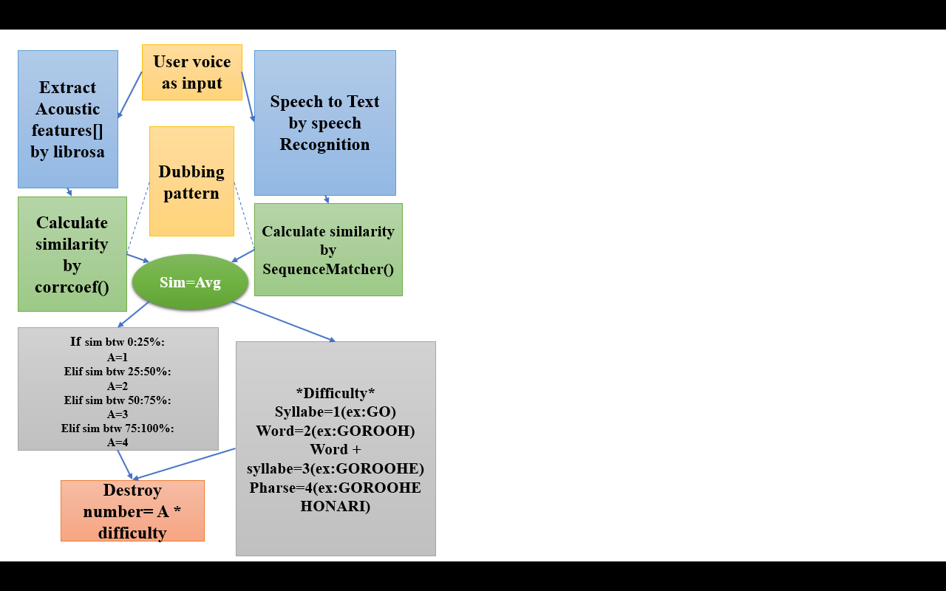

Fig. 5. The architectural diagram of the "dublor sho" strategy

## Dataset

The data set used in this study was prepared by selecting a fixed sentence from each dubber. They were spelled, worded and phrased. Then, six random arrays of syllables and words and phrases were extracted randomly from the fixed text and were randomly examined in each round of play. The phrase did not contain any particular meaning and the Farsi term "Goroohe Honari" was used. The voices were extracted from a sample of famous speakers in the dubbing area, which included 9 women and 49 men.

## Implementation and Neural Network

The ability of deep convolutional neural networks (CNNs) to learn discriminative spectro-temporal patterns makes them well suited to sound classification. Python has great libraries for audio processing like Librosa and PyAudio. At present research two libraries for audio acquisition are used:

1. Librosa which is a Python module to analyze audio signals. It has been very well documented along with a lot of examples and tutorials.

2. IPython.display.Audio which lets to play audio directly in a jupyter notebook.

Every audio signal consists of many features. The process of extracting features to use them for analysis is called feature extraction. For the present study, a series of sound features were examined, which are briefly mentioned below:

### Zero Crossing Rate

The zero crossing rate is the rate of sign-changes along a signal, the rate at which the signal changes from positive to negative or back.

### Spectral Centroid

It indicates where the “center of mass” for a sound is located and is calculated as the weighted mean of the frequencies present in the sound.

### Spectral Rolloff

It is a measure of the shape of the signal.

### Mel-Frequency Cepstral Coefficients (MFCCs)

The Mel frequency cepstral coefficients of a signal are a set of features which concisely describe the overall shape of a spectral envelope. It models the characteristics of the human voice.

the present study tries to model a classifier to classify audios into different genres. Its task is to sort them according to the being dubber or not. Before training the classification model, raw data from audio samples were transformed into more meaningful representations. The audio clips needed to be converted to .wav format to make it compatible with python’s wave module for reading audio files. Pratt phonetic software was used to convert sound formats.

To classify the audio clips, 4 features were extracted, Mel-Frequency Cepstral Coefficients, Spectral Centroid, Zero Crossing Rate, Spectral Roll-off. All the features were then appended into a .csv file so that classification algorithms could be used. Once the features had been extracted, the existing classification algorithms were used to classify the audios into different genres. Spectrogram images can also be used directly for classification or the features can be extracted and the classification models can be used on them. Using a CNN model (on the spectrogram images) gives a better accuracy. figure 6 is the canvas structure of the model used.

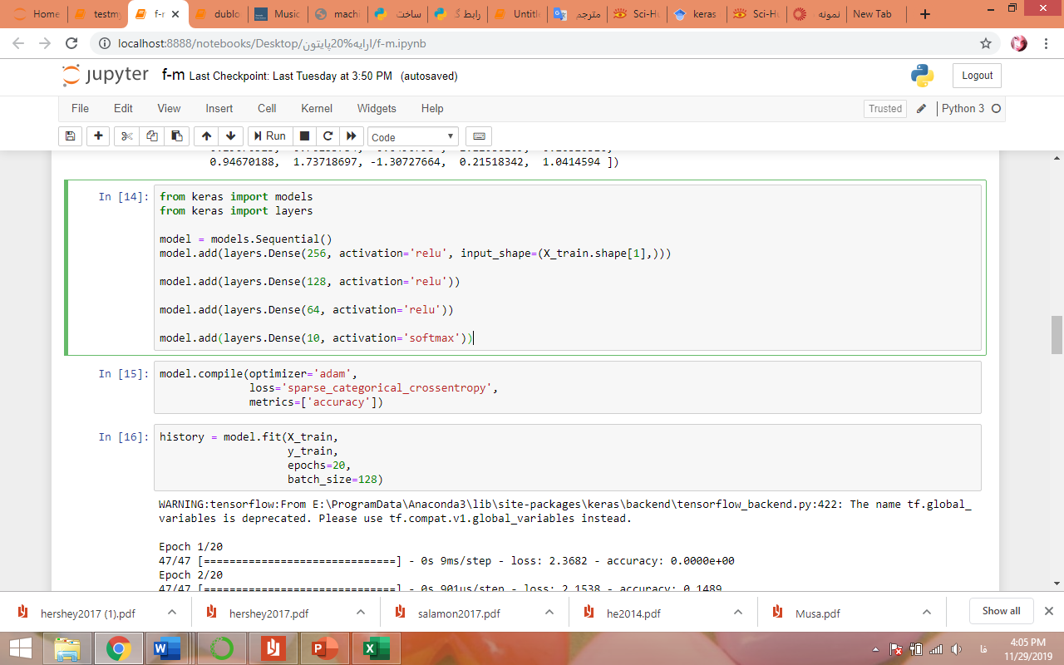

Fig. 6. Canvas structure of the CNN model

The model was fitted to the data set with 20 epoch and batch size 128 for training. The percentage of test data was 0.2. The model was able to achieve complete accuracy in a very short time (figure 7). The reason for this is the lack of data. However, the model came with subsequent tests. For this purpose, 2 dubber and 2 non-dubber sounds were entered as input and the type of sounds was correctly identified. However, the fact that all sentences were fixed and the sound of the dubbers was taken from the same source where the training sounds were selected at the test stage and the non-dubbers sounds were recorded from the laptop's microphone can be quite accurate in assessing the model impact.

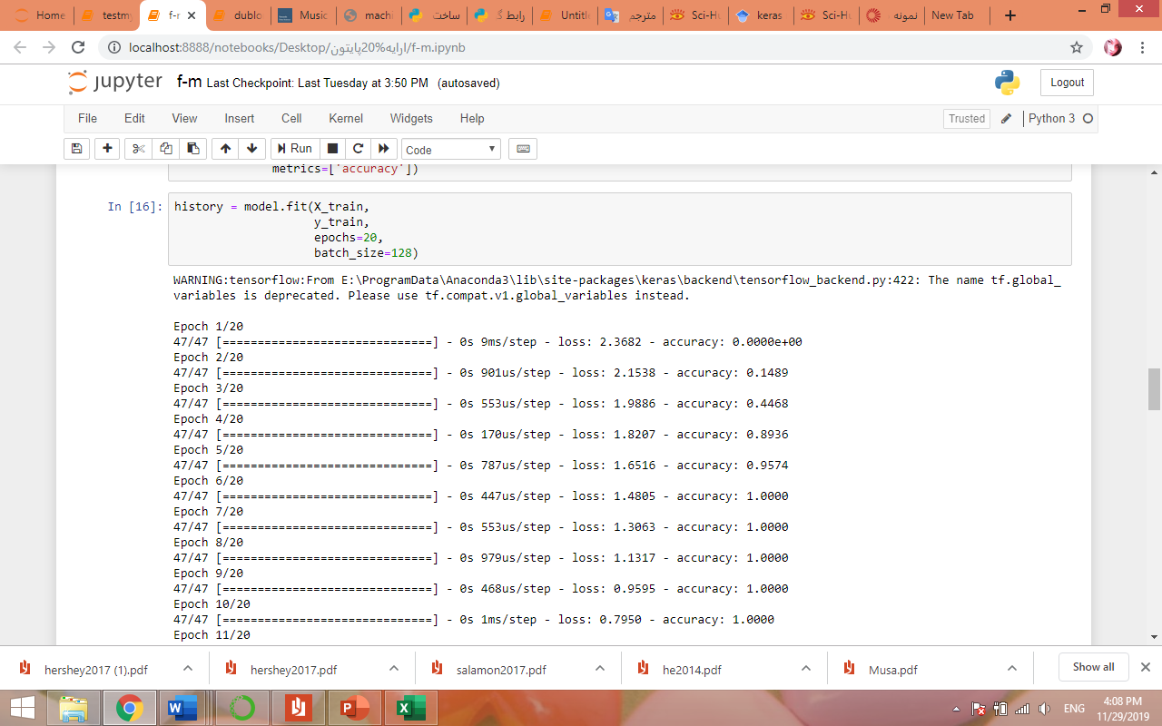

Fig. 7. Model training results

As seen in the game design architecture, this game is a brick-breaker game. In this game, the player can move forward, backward, left and right with the arrow keys on the keyboard, And select the block of text he wants. As soon as the player hits the text block, the player must express the block text in a clear voice. This sound should be as consistent as possible with the dubbers pattern. Therefore, the player must make every effort to produce quality sound. The sound expressed by the game is received, and by extracting its acoustic features, its similarity to the dubbing pattern is extracted. Then based on the similarity obtained, according to figure 8, the blue blocks are destroyed. The harder the text of the white blocks according to the ccc table, the more blue blocks are destroyed and as a result more paths are opened towards the end of the game. The player's goal in this game is to destroy himself by doubling the blue blocks.

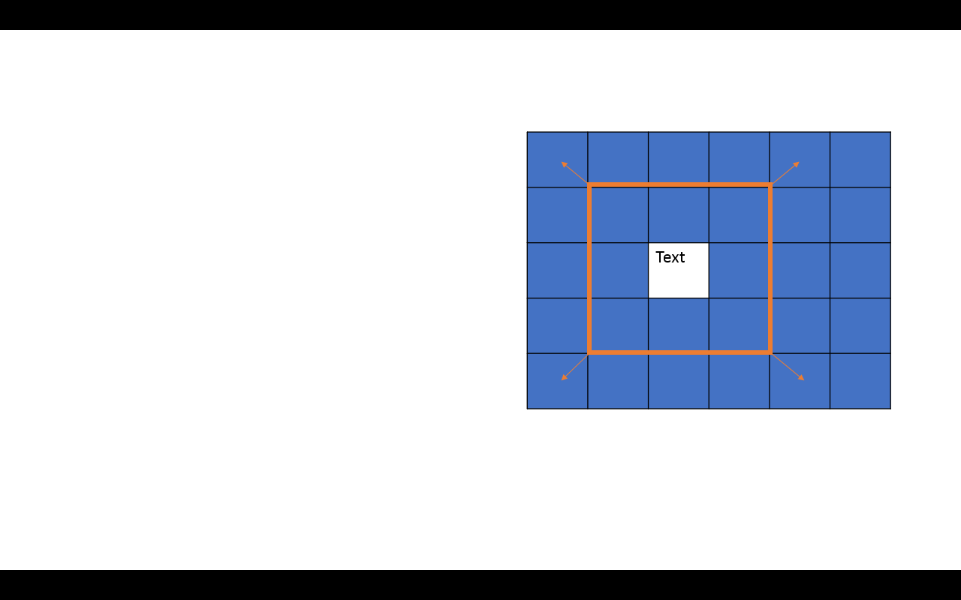

Fig.8. Depending on the destroy value of each text, the boundary unit of the blue blocks destruction around the text block becomes larger.

Since the main purpose of this game was to educate, it is not intended to be a time-consuming factor. But for the player to have to practice more words, a scoring system was designed that the more blue blocks destroyed, the more points you get. This score is exactly equal to the number of bricks. Since the number of bricks destroyed at each stage is exactly proportional to the difficulty of the text, the player will try to select the more difficult texts and reach the destination by navigating the harder path to gain more points. He said that the points earned by the player indicate that he has been able to reach dubbing art by the amount of skill.

The figure5 shows the algorithm for calculating the similarity of the input sound with the dubbing pattern and the method of calculating the score as well as calculating the number of blocks destroyed in each step. In order to calculate similarity, two factors of content consistency and acoustic characteristics were used. Finally, a mediation of these two factors was presented as the final similarity. In order to calculate the number of blocks destroyed, two parameters of text difficulty and similarity were considered which, by combining them, determined the extent of damage.

The game designed in this study was implemented by the Python programming language. The reason for using this language is that Python provides a good framework for implementing the neural network used for acoustic sound analysis and double crystalline and non-crystallized sound as well as dual sound similarity and, most importantly, acoustic analysis. On the other hand, the pygame module was used to design the game interface. Pygame is a cross-platform set of Python modules designed for writing video games. It includes computer graphics and sound libraries designed to be used with the Python programming language. In fact, in this study, the power of Python's programming language in the link between artificial intelligence, speech processing, and computer games was challenged.

It should be noted that this game does not include any background music or other popular music in the game. The reason for not using music was that it would probably not be combined with the input from the user and would not compromise the similarity calculations. It also had to be connected to the Internet to run. Because the speechRecognition library is used. This library is powered by Google and can retrieve the user's voice at a moment's notice and return it as a wav file. It can also convert speech to text by this library. Despite other offline methods for receiving voice input, this study used this library to evaluate the accuracy of the text.

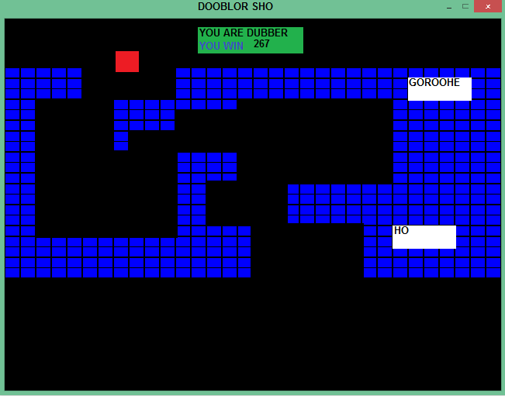

Fig.9. Scene of game

# Test

To evaluate the effectiveness of computer games in teaching voice skills, the ‘Dublor Sho” game was evaluated by four students. Since the dataset had more male specimens, therefore, male specimens were also selected to eliminate the likelihood of neural network model weakness. The sampling method was snowball and random. All participants were students of Tabriz Islamic Art University and were between 20 and 30 years old. They were all healthy in terms of phonetic health and had no specific respiratory disease and all were fluent in Persian. Participants were asked to play “Dublor Sho” game 3 rounds. The declared scores was recorded at the beginning and the end of the test for each individual.

# Result

The players' scores were recorded at the end of the first and final stages. Then their percentage scores (the ratio of points earned to the total number of blue bricks) were calculated. These percentages are used to draw a comparative graph. Since the main focus of this study was on game design, we limited the evaluation to that extent. For future research we intend to provide more accurate results on the quality of output of this research and to improve the game with more reliable evaluations and the presence of control and experimental groups.

As it can be seen in Fig.8, the “Dublor Sho” game has been able to help participants, to a good degree, learn the dubbing skills. During the interview with the participants all expressed their satisfaction and stated that they are eager for the full and graphic version of the game.

similarity

Fig. 8. Comparison of the similarity of participants' voices with the pattern of dubbers before and after test

# Concolusion

In the present study, in order to evaluate the impact of computer games on sound and dubbing art instruction, a game was designed as "Dublor Sho". In order to design this game, a set of male and female dubbers was created. Then a neural network model was trained by Dataset to extract the dubbers pattern. The game tried to score players by encouraging them to try and make their sound a little better by extracting the sound features and comparing them to the pattern extracted from the dubbers. Eventually, after evaluating the game, it was concluded that the game was successful and in the future will try to provide a graphical version of the game.

##### Acknowledgment

This article is based on a master thesis of Intelligent Design Simulator by the title of “Examining the Effective Variables of Speech phonology in the Origin of the Audience with the Approach of Simulating Persistent Voices in Dubbings”, a research by Yasman Saffari, under the guidance of Dr. Abbas Ghaffari & Dr. Leila Doubakhti & Dr. Behnam Alizadeh Ashrafi in Tabriz Islamic Art University.

[1] T. Overath, J. H Mcdermott, J. Mary Zarate and D. poeppel, "The cortical analysis of speech-specific temporal structure revealed by responses to sound quilts," Nature neuro sience advance online puplication, 2015.

[2] V. Lyberg, M. Hlander and H. Jonas, "Does the speaker’s voice quality influence children ’ s performance on a language comprehension test?," 2015.

[3] Fernanda, IOnofre, Y. d. Almeida prado, G. Vannesa E Rojas, D. M. Garica, L. Aguiar Ricz and R. Preto, "Measurements of the Acoustic Speaking Voice After Vocal Warm-up and Cooldown in Choir Singers," 2015.

[4] E. Monti, D. C, Kidd, L. M, Carrol and E. Castano, "What’s in a singer’s voice: The effect of attachment, emotions and trauma," 2016.

[5] M. Eslami, J. SheykhZadehGan, Z. AhmadiNia and A. BahramiRad, "Steps and how to prepare syllabic and diaphonic audio data for Farsi Text Conversion System,”Signal and data processing”, 2009.

[6] S. Sengupta, G. Yasmin and A. Ghoal, "Speaker Recognition Using Occurrence Pattern of Speech Signal," Recent trends in signal and image processing, vol. 727, 2019.

[7] A. v. d. Oord, S. Dieleman, H. Zen, K. Simonyan, O. Vinyals, G. Alex, N. Kalchbrenner, A. Senior and K. Kavukcuoglu, "WaveNet: A GENERATIVE MODEL FOR RAW AUDIO," 2016.

[8] S. O.Arik, J. Chen, P. Kainan, W. Ping and Y. Zhou, "Neural voice cloning with a few samples," in 32nd conference on neural information processing systems, Montreal, 2018.

[9] A. Dehghan, "Analysis of Acoustic Parameters of Voice of Natural Persian-speaking People in Zahedan, 2008.

[10] M. Sharif Nughabi, H. Marvi and D. Darabiyan, "Identifying Farsi Speech Speech by Speech Signal Using Efficient Attribute Extraction Methods and Class Combinations," Signal and data processing, 2016.

[11] C. N. Anagnostopoulos, T. Iliou and I. Giannoukos, "Features and classifiers for emotion recognition from speech: a survey from 2000 to 2011," Artificial Intelligence Review, vol. 43, no. 2, 2015.

[12] J. Rao, F. Ture, H. He, O. Jojic and J. Lin, "Talking to Your TV: Context-Aware Voice Search with Hierarchical Recurrent Neural Networks," 2017.

[13] S. A.Bell, "The dB in the .db: Vocaloid Software ad Posthuman Instrument," popular Music and society, 2015.

[14] M. Blaauw, J. Bonada and R. Daido, "DATA EFFICIENT VOICE CLONING FOR NEURAL SINGING SYNTHESIS," 2019.

[15] M. Pivec and P. Kearney, "Games for Learning and Learning," Organizacija, vol. 40, 2007.

[16] P. Duysburgh, K. Mouws, K. Slegers and M. Nouwen, "Playful Sounds From The Classroom: What Can Designers of Digital Music Games Learn From Formal Educators?," Crossings, 2015.

[17] R. dos Passos Canteri, L. Sanchez Garc ´ ´ıa, T. Amara Felipe, L. Fernandes Oliveira Galvao and D. Roberto Antunes, "Conceptual Framework to Support a Web Authoring Tool of Educational Games for Deaf Children," in International Conference on Computer Supported Education, 2019.

[18] Brennan, E. W. U.S. Patent No. 8,138,409. Washington, DC: U.S. Patent and Trademark Office 2012.

[19] K. Don, C. Gianna, B. Scott and M. Raymond A.R., "Music emotion classification by audio signal analysis: analysis of self-selected music during game play," in 10th International Conference on Music Perception and Cognition, 2008.

[20] k. H. Dong, Z. Shouming , G. Bi and Y. Rui , "The poultry voice classification model based on EMD and Support Vector Machine," Mechanics and Materials, vol. 722, 2014.

[21] S. Hershey, S. Chaudhuri, D. P. W. Ellis, J. F. Gemmeke, A. Jansen, R. C. Moore, M. Plakal, D. Platt, A. S. Rifs, R. A. Saurous, B. Seybold, M. Slaney, R. J. Weiss and K. Wilson, "CNN ARCHITECTURES FOR LARGE-SCALE AUDIO CLASSIFICATION," in International Conference on Acoustics, Speech and Signal Processing (ICASSP), New Orleans, LA, USA, 2017.