***Synergistic nature of digital game-based language learning and Task-based language teaching***

Saba abdolmohammadi vahid

Department of English language and literature

Tabriz university

Tabriz, Iran

Saba.v@outlook.com

Task-based language teaching is a prominent advance in the science of second language acquisition, it suggests the way of learning by doing meaningful activities that we do in our real life situations. Task-based language teaching scholars assert that traditional language excercises and artificial contexts that are sprout out of the mind of an author or authors will not provide a fruitful environment for language learning and what we need to have an effective language learning is a meaningfl and graded collection of tasks to be done by learners. Serious games tend to provide opportunities for Task-based language teaching, synergetic coexistence of digital game based language learning, task-based language learning and learning by doing has been studied in this paper, considering the affordances that are brought by implementing a well designed game .

task-based language teaching, DGBLL, digital game-based language learning, learning by doing, immersive environments

# Introduction

There have been tons of researches regarding the effectiveness of serious games in educational contexts, and it is not the sole aim of this paper to replicate another successful statistical finding. In more details, this paper will try to show the underlying conformation of serious games’ principles and task-based language learning’s principles, and reach the conclusion that using games is a must to reach the potentials in task-based language teaching methodology and it is hard to have a true task-based language learning environment without using serious games.

Task-based language learning has been a hot topic for the last two decades. It rejects the traditional way of present and practice manner of teaching. It defines language learning as a whole learning process, which is not a linear and predefined package introduced by a teacher-oriented classroom. Every student is unique, with specific abilities and interlanguage, and specific needs and zone of proximal development. there is no single medicine to cure all the patients (long, 2014 pp.10). What used to be a typical classroom with the teacher in the center as the provider of learning context and initiator of classroom discussions is rejected in task-based language learning. Learner centeredness and individualized treatment are two of the key points which is illustrated in task-based language learning blueprint, alongside situational authenticity and meaning oriented activities, but achieving such a promise and implementing a true task-based environment is a complicated mission to accomplish by current system of education and traditional classrooms which limits the boundaries of experiment to disengaged environments of classrooms. At the same time we are in a period which serious games are evolving and flourishing and magically the principles of task-based learning matches the affordances that serious games can provide and the burst of new studies regarding the use of games and technologies in service of task-based language learning is happening. In this paper researcher designed, developed and implemented a serious game called Vanlifer by considering the task-based language learning principles and measured the difference of interactional patterns among control and experimental groups.

# current issues

## general statement of the issue regarding task-based language learning

It seems that implementing a highly successful task-based language teaching and providing all the required principles is a taunting Task for a single teacher, if not impossible. So, a need for help in this case is undeniable for a teacher, to reach a highly successful task-based language teaching environment with elaborated input and rapid negotiation of meaning we need an economic environment that can provide real world tasks inside the boundaries of the classrooms.

## Issues regarding individualized teaching in task-based language learning.

The problem starts with diagnosis of language learners and defining a learner’s exact level of proficiency in a second language like English, it requires more than a single test and interview (long 2014 pp.76), and as this issue is discussed in many aspects of language testing related papers and many solutions have been proposed, like longitudinal tests, being portfolios and alternative assessments, there are still problems like inter-rater reliability and intra-rater reliability, alongside the economy of time for a single teacher to conduct such an elaborated diagnosis. This step is crucial to have an individualized teaching environment, which is crucial to task-based language learning. What the magic of digital games can provide for this issue is the ability to test the huge amount of users with complicated algorithms through meaningful task inside the games and not letting the users know that they are being tested to reduce the affective factors to the minimum and this has never been possible before existence of serious games.

## Issues regarding authenticity in TBLT

Authenticity is another issue related to TBLT (Task-Based Language Learning), and it has been centered around the authenticity of input alone, resulting in a more text based language learning environment than an authentic one, and the other aspect which is situational authenticity, is not discussed much among applied linguistics scholars and teachers, because of its difficulty of being provided to a classroom. How is it possible to provide an authentic environment to a classroom, like a train station, or an airport or a factory or a kitchen. Even if an organization tries to do that, it will be extremely costly, but its importance for education has been a favorite discussion among few of scholars for at least a century. Ferrer’s Escuela Moderna and Sebastien Faure’s school, La Ruche (The Beehive) were radical changes in their time to bypass the boundaries of the limited classrooms, by taking students outside and to the fields, producing real things like cheese and butter and then cultivating or going to visit factories and museums, respectively in 1901 and 1904, to get their hands on authentic environment (Suissa, 2006).

## Issues regarding learner centredness in task-based language leaning

Learner centeredness is another issue which responds to the fact that the linear and predefined syllabus will not work in task-based language learning and traditional interactional patterns in classroom being IRF(teacher initiation, student’s response and teacher feedback) and IRE(teacher initiation, student’s response and teacher Evaluation)( [JK Hall](https://scholar.google.com/citations?user=I0RUyMwAAAAJ&hl=en&oi=sra) & [M Walsh](https://scholar.google.com/citations?user=1rgQzTgAAAAJ&hl=en&oi=sra), 2002) Are not useable in task-based language learning. Students need to start a conversation when they like and when then need (long, 2014 pp77), and it is not an obligation for a human to talk in an environment like a classroom in order to learn a language, it is against the whole learning approach and affectional factors. So there must be other choices for students to conduct a communication. The use of Internet technology for telecollaboration has been one impetus for an expanded theoretical framework drawing on sociocultural theory (e.g., Lantolf, 2000; Lantolf & Thorne, 2006). In this case the use of serious games is also the most economic way to provide a learner centered environment and the emergence of smart phones which can conduct a serious game in any desired place can fulfill the promise of portability and flexibility that has never happened before. Learners can start the educational session when ever they feel prepared and can communicate with any peer in any place of the world just by few taps on the screen.

## Issues regarding meaning orientation in task-based language learning

Creating meaning-oriented tasks is another upheaval to reach a task-based language teaching classroom, it says that tasks should reach an outcome which has resemblance to real life activities (Ellis, 2003). there are many tasks in real life which are language oriented and require receptive or productive response, like a physics lab’s instruction for a student to reduce the voltage on a generator before reaching a certain level, and tons of other examples which need external infrastructure to conduct such important tasks. Currently task-based language learning is conducted through roleplaying and text-based tasks (Willis D & Willis J, 2007). To conduct a better task-based language teaching classroom we need tasks which doing it will be sensible and meaningful, and also should be replicable in real life, and the boundaries of a classroom is not a medium to bring this feature to the learner. Here again we can find the traces of serious games as the economic solution to bypass the issue. There is no other way to provide a meaningful task like using an ATM (automatic teller machine) in second language like English, or following a second language instruction for using a device. The only economic way is generating the virtual environments through digital technologies and coupling the digital reality with meaningful activities through game mechanics in serious games.

## Issues regarding creating feedback in TBLT

Feedback and negotiation of meaning is another principle in Task-based language learning which is stablished based on sociocultural theory of mind (Vygotsky, 1987). a median, which is an entity with higher level of proficiency can provide feedback in zone of proximal development of a student to develop a learner’s language. Scaffolding and its several mean of conduction is at the core of the idea. It is obvious that scaffolding should be made by someone, and it can be done by a teacher or other peers(Ellis, 2003), the issue is that it is not feasible for a single teacher to be present at any time of the day to provide feedback, or even in a single session of a classroom, there may be times when the teacher is exhausted and misses some opportunities to make required feedbacks, besides the fact that all the teachers are not capable of making the right kind of feedbacks. Here we can make maximum use of serious games and artificial intelligent agents to scrutinize the learners’ utterances and generate a feedback at any time of the day. Also we can replicate the most effective ways of scaffolding by sampling the most successful teachers and scholars generated feedbacks and create an algorithm to enhance it by machine learning and deep learning affordances.

# Task-based language teaching and digital games

Digital game-based language learning is now a field of study in its own right. Lots of researches has been conducted around the issue and its effectiveness has been proved, especially in grammar oriented and linguistically planned games. (Hung et al,2018). There has been a trend in using commercial games for language learning purposes, although it was a new and exciting era to discover, the results were not as it was supposed to be and the engagement of the learners did not result in language acquisition (Hung et al,2018). The need for linguistically adjusted games or serious games were felt among scholars but the developing such games was a hard task to be done. Because of the

In this research, we have used a researcher built digital game (Vanlifer) with Task-based considerations in its design. The research is conducted within a Master thesis in Tabriz university, to measure the effects of a task-based digital game on learners, and the results were fruitful. The aim of research is to find the effect of using a task-based digital game on the communication of the students in the classroom. As long as we pointed out before, task-based language learning is based on sociocultural theory of mind, and sociocultural theory of mind states that learning is a social activity and a learner learns when engaged in communication with others, so to justify our applications use and its relation to task-based language teaching, it should generate more communication.

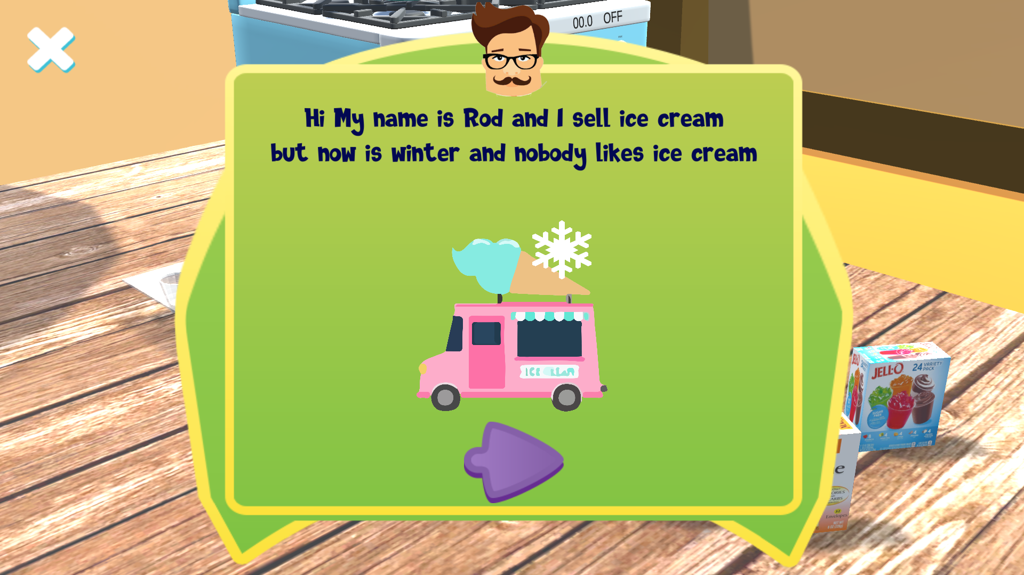

Figure 1. first menu of the game

# Method

## This research uses a quasi-experimental design that contains two experimental groups and a control group. Experimental groups will benefit an android game to do their homework; while the control group will use a traditional text-based home-work. 60 students are engaged in this study. Their English proficiency is at the same level measured by the Oxford proficiency test. The control group consists of 11 students whose ages range between 16 to 21. There are two experimental groups which totally consist of 29 students, one of them has 15 and the other 14 students. Students are chosen from pre-intermediate classes.

This study is conducted in a private institute in Tabriz which contains four classes for pre intermediate EFL students. these classes has both genders and the classes are held 2 days a week. The conventional curriculum of the class enjoys authentic published books by oxford university press called Solutions. Students attend the classes regularly. Teachers are of different fields of study which have gone through an English proficiency test and attended a teacher training course by the respected institute. this game is in 3d environment and is based around a task that should be completed. It took around 15 months for the researcher to learn the technologies and programming skills needed to develop the game, being C sharp programming language, Microsoft visual studio dot net, Jetbrains rider, JSON, unity3d game engine, blender technologies, audacity software, and photoshop. The game consists of several thousands of lines of code and many 3d models. speech recognition ability is derived through google speech recognition code library. The game will simulate the making of a gummy candy. users are able to listen to orders and use the smartphone’s touch screen capabilities to move objects around and complete the task. this game can provide a post-task vocabulary activity which will provide a car racing environment which will pronounce some objects’ name and the player should drive through the proper icons on the road to get more scores. although this activity is residing outside of whole learning approach and is more of rote learning, as long as it is a focused and post-task, it will not harm the sociocultural basis of the developer's aim for making a task-based game. The same task of making gummy candy will be provided by a traditional and text-based format for the control group and the sample which be handed to students to work on is presented on the next page. Text-based task is only a simple recipe. A laptop computer will be used for recording the class activities as an undercover video capture device. We also used Oxford placement test to select our participants in a homogenous manner.

Two experimental groups are treated by a digital game available on android devices to do tasks in a 3d virtual world and one control group will be handed a traditional text-based assignment to do at home. The content and vocabularies are the same as each other in the text-based home assignment and digital task-based game home assignment. Students in the experimental group will use the game at home which is consisted of buying ingredients for making gummy candy, and explanation about making those. The control group will receive a hard-copy paper by the teacher which has the list of ingredients and a recipe to make gummy candy. During the next session of assignment of homework, the teacher will spend 15 minutes to do a paired group consensus task and will ask students to talk about how to make gummy candies, during the task, a video recorder will record the class conversations.

the following guidelines were applied for both recordings:

Because we have two independent factors to investigate, one factor being using of digital game and the other being gender, After recording the conversation, the total student talk time will be measured and will be analyzed by two-way analysis of variances (ANOVA) between groups, to see if there is a significance in group differences. To measure the student participation, we use a method that was used in a study to compare student achievement and student cooperation in classroom activity(Klara et al, 2019).‘We only counted student utterances that were part of whole-class teaching that involved interactions between the teacher and students and among students. We excluded such types of talk as reading a text, individual work, and group work. We also excluded any talk that did not relate to the subject matter at hand (for example, organizational matters).’ We based our method on the classification of student utterances proposed by Pimentel and McNeill (2013): (1) no response, (2) word/phrase, (3) complete thought (resembles a sentence but no explanation of thinking is included), and (4) thought and reasoning(resembles a sentence and includes explanation). In this study, we will count the number of incidents belonging to the third and fourth categorizations. recorded videotapes will be transcribed and then counting will be processed.

## V. Results

The first research question of the study made an endeavor to specify the differences between the interactional patterns of the EFL learners who carried out the digital game task of the study in the experimental groups and the ones who were provided with the pertinent consensus task which was utilized in the control group. The results accentuated the fact that the treatment of the study had a beneficial impact on students’ participation and the number of utterances in the course of task performance. To be more specific, the number of utterances that signified and evinced the learners’ thoughts and reasoning increased significantly in the experimental groups of the study. These results are in line with the results of the studies by van Eck and Dempsey (2002), Kinzie and Joseph (2008), Hoshino et al. (2009), Kim, Park, and Baek (2009), Yien, Hung, Hwang and Lin (2011), and Wei Peng et al. (2016).

Kinzie and Joseph (2008) pointed out that, digital games might have an advantageous impact on EFL learners’ proclivity to take part and carry out the learning tasks in an efficient way. They noted that the utility of these kinds of tasks stems from their goal-oriented nature. More specifically, digital game tasks prompt the learners to participate in task performance due largely to the fact that they pursue specific and predetermined objectives. Furthermore, these tasks provide the learners with a delightful experience which may lead to significant interaction among the group members. They concluded that the supportive classroom atmosphere which is created during the performance of these tasks might result in constructive learner interaction in the context of the classroom.

Similarly, Prensky (2001) contended that digital game tasks facilitate the cognitive processes which play a major role in the use of the second language for authentic purposes. As he noted, these tasks direct the learners’ attention to particular aspects of the target language and prompt them to process the pertinent formal aspects and utilize them in their productive language use. More specifically, the primary analysis and processing of the language forms facilitate and expedites their processing in second language interactions and escalates the learners’ participation and the number of second language utterances in the course of task performance.

Consequently, it can be contended that in the present study the utilized digital game task had a beneficial impact on the learners’ interactions and participation in task performance since it: a) was goal-oriented and encouraged the learners to carry out the task to accomplish a genuine objective; b) created a supportive and friendly classroom atmosphere in the course of task performance, and c) facilitated and expedited the learners’ processing of the various aspects of the target language in task performance

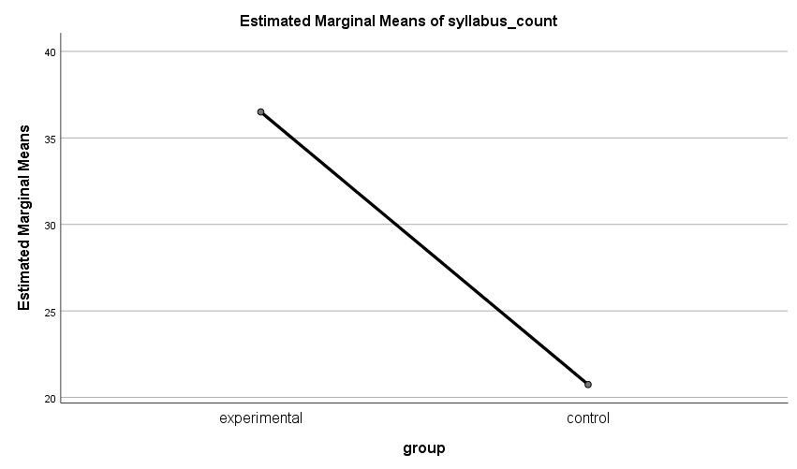

*Figure 2*. the difference of mean between groups

The second research question of the study made an effort to determine the differences between the interactional patterns of male and female EFL learners’ who carried out the relevant digital game task of the present study. The results underscored the fact that there was not a significant difference between the interactional patterns of these groups of learners. To be more specific, male and female EFL learners produced a similar number of utterances and participated in an equal way in the pertinent task. These results support the results of the studies by Harris and Reid (2005), Burguillo (2010), Huang, Huang, and Tschopp (2010), Wang and Chen (2010), and Dickey (2011).

Burguillo (2010) stated that digital game tasks might have a favorable effect on both male and female language learners’ participation in task performance. He noted that these tasks intensify all of the learners’ motivation to acquire the various aspects of the target language in order to understand the diverse features of the pertinent game. The learners’ mastery over the formal aspects of the target language may have a positive effect on their predisposition towards participation in task performance and interaction with their group members.

Moreover, as Peterson (2013) argued, the use of digital game tasks has an advantageous effect on both male and female language learners’ participation in task performance. He explained that the use of these tasks is congruent with the prevalent approaches to second language learning including Communicative Language Teaching (CLT) due to the fact that the aforementioned tasks are absorbing for all of the learners and encourage them to negotiate the meaning of target language utterances in task performance and internalize their accurate use in the target language.

Furthermore, Young et al. (2012) contended that both male and female learners can benefit from the utilization of digital game tasks since these tasks expose them to the authentic use of the target language and decrease their language learning anxiety through the development of a constructive learning environment. As they noted, the congenial atmosphere which is created by means of the pertinent digital game tasks reduces the affective barriers which might be present in traditional task performance for all of the groups of language learners.

Finally, Boyle et al. (2016) noted that digital game tasks might have a constructive role in the context of the classroom for both the male and female language learners due to the fact that they prompt the learners to initiate the use of the target language in the course of task performance and encourage them to process the formal aspects of the target language and to internalize them by means of their peers’ assistance. As they stated, the male and female learners’ initiation of language use as a result of peer assistance increases their participation in the process of task performance.

Therefore, it can be stated that in the present study there was not a significant difference between the male and female language learners’ participation in digital game task performance since these tasks: a) escalated both male and female learners’ language learning motivation; b) facilitated male and female learners’ negotiation of meaning during task performance; c) reduced the male and female learners’ affective barriers, and d) prompted the male and female learners to imitate the use of the target language in the relevant tasks.

Table 1. Tests of Between-Subjects Effects



# Conclusion

As was mentioned in previous chapters, the aim of this study was to find out whether using a digital game designed by task-based considerations improves the interactional patterns of students better than the traditional method does or not. The findings of the study proved that using the digital game had a positive effect on students’ interactional patterns. In the case of student engagement and student talk time students in the experimental group outperformed those in control group. The result of the study can be considered as a support to Hsiu-Ting Hung (2018) who claimed that digital game-based language learning has positive effects on language learning, especially related to affective and psychological states, closely followed by language acquisition.

As it is clear, the researcher posed a research question and then he asked how the use of digital games affects the students' talk time and interactional pattern. The researcher tried to develop a digital game in a period of 13 months to find a good answer for the research question and as a result, he proved that because of students’ interest in using computer games and especially on mobile devices, they are really interested and attracted to use mobile digital games rather than traditional and text-based methods that most of the teachers use. In a traditional method, it is common to face students’ excuse about doing their homework, from having another exam in high school or university, to other causes and reasonings. But the use of digital games in experimental groups broke that tradition and almost all the students spent time on homework.

##### References

1. Long, M. H. (2014). *Second Language Acquisition and Task-Based Language Teaching*.J.
2. Suissa, J. (2006). *Anarchism and education. A philosophical perspective*. London: Routledge.
3. Hall, J. K., & Walsh, M. (2002). 10. *Teacher-Student Interaction And Language Learning*. ACM Sigapl Apl Quote Quad, 22, 186–203.100, 3, 455–471.
4. Lantolf, J. P. (2000). Second language learning as a mediated process. Language Teaching, 33(2), 79–96..
5. Lantolf, J. P., & Thorne, S. L. (2006). *Sociocultural Theory and the Genesis of Second Language Development*.
6. Ellis, R. (2003). *Task-based Language Learning and Teaching*.
7. Willis, D., & Willis, J. (2007). *Doing Task-based Teaching*.
8. Vygotsky, L. (1987). *The collected works of L.S. Vygotsky*.
9. Hung, H. T., Yang, J. C., Hwang, G. J., Chu, H. C., & Wang, C. C. (2018). A scoping review of research on digital game-based language learning. *Computers & Education*, *126*, 89-104.
10. Pimentel, S. D., & McNeill, K. L. (2013). Conducting talk in secondary science classrooms: Investigating instructional moves and teachers' beliefs. Science Education, 97, 367–394.

[11] Peterson, M. (2016). The use of massively multiplayer online role-playing games in CALL: An analysis of research. Computer Assisted Language Learning, 29(7), 1181-1194.

[12] Van Eck, R., & Dempsey, J. (2002). The effect of competition and contextualized advisement on the transfer of mathematics skills a computer-based instructional simulation game. EducationalTechnology Research and Development, 50(3), 23-41.

[13] Kinzie, M. B., & Joseph, D. R. (2008). Gender differences in game activity preferences of middle school children: implications for educational game design. Educational Technology Research and Development, 56(5-6), 643-663.

[14] Hoshino, J., Saito, T., & Kazuto, S. (2009). Task-Based Second Language Learning Game System. In ICEC ’09 Proceedings of the 8th International Conference on Entertainment Computing (pp. 323–324).

[15] Lee, S., Noh, H., Lee, J., Lee, K., Lee, G. G., Sagong, S., & Kim, M. (2011). On the effectiveness of robot-assisted language learning. ReCALL, 23(1), 25-58.

[16] Yien, J. M., Hung, C. M., Hwang, G. J., & Lin, Y. C. (2011). A game- based learning approach to improving students' learning achievements in a Nutrition course. *Turkish Online Journal of Educational Technology-TOJET*, *10*(2), 1-10.

[17] Boyle, E. A., MacArthur, E. W., Connolly, T. M., Hainey, T., Manea, M., Kärki, A., & Van Rosmalen, P. (2014). A narrative literature review of games, animations and simulations to teach research methods and statistics. Computers & Education, 74, 1-14.

[18] Peng, W., Crouse, J. C., & Lin, J. H. (2013). Using active video games for physical activity promotion: a systematic review of the current state of research. Health education & behavior, 40(2), 171-192.