Wastewater Reuse of Rainbow Trout Earth Ponds to Increase Production in Earth Farms

Akram Bemanikharanagh¹ - Morteza Alizadeh²

¹Department of Environmental Science, Faculty of Agriculture and Natural Resources, Ardakan University, Ardakan, Iran (a.bemani@ardakan.ac.ir)

² Inland Salt Water Fishery Research Station, Iranian Fisheries Science Research Institute

a.bemani@ardakan.ac.ir

ABSTRACT
This study was carried out in a brackish water earth farm in Bafgh, to reuse wastewater of earth ponds in order to increase production in rainbow trout earth farms. It was performed in 2 treatments with 2 replications. For this purpose, four 0.5ha earth ponds (two of those with 30 m³ round cement ponds at the end and others without cement ponds) were made. The wastewater of culture earth ponds flew in cement ponds through pumping and gravity. The cement ponds aerated with splash aerator during nights. The average initial weight of fish for stocking in all ponds was 25 g and density of stocking was one and 70 fish per square in earth pond and cement pond, respectively. During about 120 days culture period, water temperature and salinity was 14±4 °c and 12.8±1 g/l, respectively. The results of some chemical factors measuring in cement ponds indicated that none of them was critical during culture period. There were significant differences among treatments on some growth factors (p<0/05). According to The results, through reusing of earth ponds wastewater, yield quantity and production income increased up to 31% and 41%, respectively.

Keywords: brackish water, earth pond, oncorhynchus mykiss, waste water reuse and rainbow trout

introduction
INTRODUCTION
Fresh water is vital to sustain human life, however, only 3% of total water on earth is fresh water and two-thirds of that is in frozen forms such as the polar ice caps, glaciers and icebergs. The remaining 1% is either surface water or ground water.
Industrial development resulted in ever-increasing water consumption as well as water pollution. Population Continuous growth has increased the demand for water and looking for alternative water sources by water agencies. In order to handle increased water demand, the treated wastewater has to be reused .In addition to conserving highly treated, expensive drinking water; wastewater reuse reduces the release of nutrient-rich wastewater into environmentally stressed streams and rivers [1]. The most common reasons for establishing a wastewater reuse program is to identify new water sources for increased water demand and to find economical ways to meet increasingly more stringent discharge standards.
Nutrient recycling efficiency and economic aspects should be explicitly stated when reporting the efficiency of aquaculture system. Reporting overall purification results (effluent/influent) is not enough. Sound nutrient budgeting is an important step towards improving the functioning of aquaculture plants [2]. So, reuse of wastewater for aquaculture may be a proper approach to consider multiple exploitations of water resources and development in aquaculture sector through using non drinkable water to cultivate protein products.
In a recent study on limnology of rainbow trout earth ponds in Bafgh area (Yazd) specified that wastewater quality of these ponds regard to semi-intensive culture system, was proper and no signs based upon high load of pollutants in wastewater founded [3]. Taking into consideration importance of water in studied area and appropriate quality of earth ponds wastewater, protein products culture in an aquaculture wastewater reuse system would be an environmental as well as economic occupation. In this research, it have been tried to investigate economic and environmental aspects of this system.

METHODS AND MATERIALS
Experimental design
This study was conducted in a brackish water earth farm in Bafgh (Yazd). The main object of this research was to increase production of rainbow trout (oncorhynchus mykiss) through reusing wastewater of earth ponds which established for rainbow trout (oncorhynchus mykiss) farming.
Executive operations and material preparation of project carried out in summer 2004. For this purpose, four 0.5ha earth ponds with the same dimensions (100×50×2.5m) were selected. The experiment included two treatments (T1 and T2) by two replications. Demanded water for earth ponds supplied through well water. The main phase of project performed in autumn and winter 2004.
Each treatment consist of 2 earth ponds (with cement ponds and without cement ponds at the end) the cement ponds were round, 6 meters in diameter, 30 tons in volume and were made in the corner of earth pond near to outlet (fig. 1). The water exchange of earth ponds flew in cement pond through pumping and gravity, although it was possible the water exchange through main outlet of earth ponds if it was necessary. The cement ponds aerated with splash during nights.
Stocking accomplished by 24000 juvenile rainbow trout with the initial weight of 25g for earth ponds (every pond 6000 fish) and 4200 fish for cement ponds (every pond 2100 fish). The density of stocking was 1 and 70 fish per square meter in earth pond and cement pond, respectively.
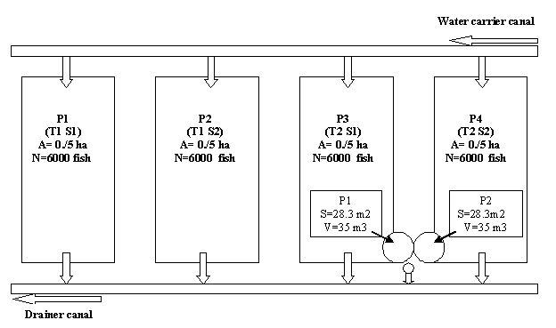
Fig. 1: General layout of project
Fish were fed by GFT1 at the first month and by GFT2 pellets until harvest. Some growth factors such as WG, FCR, CF and some environmental indices such as water temperature, pH, salinity and dissolved oxygen measured in 15 days intervals. Some other factors included nitrate, nitrite, ammonium, phosphate, sulfate and Sechi depth measured weekly.

Analysis
Growth data were analyzed using SPSS software and paired T analysis. The significant differences were determined in %5 level. In order to compare factors, biomass index was used to provide same condition for treatments.

RESULTS
Environmental factors
Values of measured environmental factors have been showed in figure 2. Because of low evaporation in culture period and continuous water exchange (about 5% of earth pond volume per day); Water salinity in studied treatments was relatively constant. Fluctuation of water temperature in earth pond were between 10 to 18°c and it was not observed notable differences among temperature between earth ponds and cement ponds, although The least and most water temperature related to cement ponds (T2).

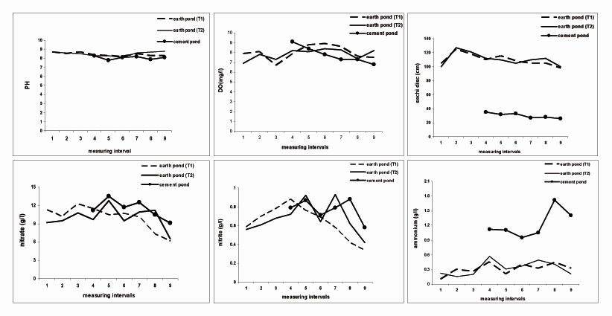
Fig. 2: Environmental factors curves. None of them were critical during culture period.

Growth indices
Statistical results (table 1) in this study showed that there was significant difference among FCR, final biomass, BWi% and final survival between treatments (table 2) . The most final survival (92%), mean daily growth (63.3 gr), FCR (1.53) and CF (1.48) related to cement ponds of second treatment. The most total length (32.3 cm) related to earth ponds of second treatment. Considering results of earth ponds of each treatments demonstrated that there was no significant difference among FCR, but difference between final biomass and final survival indices was significant. The most final biomass and final survival related to earth ponds of first and second treatment, respectively (table 3). However, in overall results, also the most final biomass related to second treatment.

Table 1: growth performance of rainbow trout

Factors | T1  (Earth pond) |  | T2  (Earth pond + cement pond)
Factors | R1 R2 |  | R1 R2 |  | R1 R2
Initial weight (g)  Final weight (g)  BWi (%)  Daily growth (g)  Final survival (%)  Final biomass(kg)  FCR  Total Length (cm)  CF (%) | 25±3.5  410±63.5  1540  2.87  85  2091  1.37  31.18±1.12  1.27 | 25±3.5  435±42.6  1640  3.05  88  2296  1.33  32.20±1.21  1.30 | 25±3.5  395±38.3  1480  2.76  91  2156  1.30  30.90±1.75  1.33 | 25±3.5  420±42.7  1580  2.94  86  2167  1.36  32.3±1.68  1.24 | 31±4.3  340±34.5  997  3.35  92  657  1.48  28.5±1.15  1.46 | 31±4.3  365±31.8  1077  3.63  89  682  1.53  29.10±1.52  1.48
Values are means ± standard deviation.

Table 2: Comparison some growth factors between treatments
Factors | T1(earth pond) T2 (earth pond +cement pond)
BWi (%)  Final survival (%)  Final biomass  FCR | 1590 b  86.5 b  2193.5 b  1.35 b | 2567 a  89.5 a  2831 a  1.41 a

Mean values in horizontal rows with different letters indicate significant differences (Paired T test; P<0.05).
Table 3: Comparison some growth factors between treatments only in earth ponds
Factors | Earth pond
Factors | T1 T2
Final survival (%)  Final biomass  FCR | 86.5 b  2193.5 a  1.35 a | 88.5 a  2161.5 b  1.33 a

Mean values in horizontal rows with different letters indicate significant differences (Paired T test; P<0.05).

Economic analysis
Results of some measured economic factors in each treatment separately have showed in table 4. These studies demonstrated that there was significant difference among final total income between treatments, but no significant difference among earth ponds in treatments founded (table 5). According to the results, the ratio of T2/T1 in term of some economic factors has been shown in table 6.

Table 4: Analysis of some economic parameters in studied treatments
Parameters | T1 | T2
Parameters | Earth pond | Earth pond | cement pond
Final production (kg)  Total cost (1.84$/kg)  Total sale (2.43$ /kg)  Total income ($/T)  Total income ($/R)  Final total income (%/T) | 4386  8059.27  10690.87  2631.6  1315.8  24.61 | 4323  7943.51  105373.12  2593.8  1296.9  24.61 | 1339  2148.71  32638.12  1115.09  557.5  34.16
 | 4386  8059.27  10690.87  2631.6  1315.8  24.61 | 34.74
($/T): Total income in every treatment
($/R): total income in every replication of treatment
(%/T): % in every treatment

Table 5: comparison of total final income in treatments
Factors | Total final income (%/T)
Only in earth ponds  T1  T2  In earth ponds and cement ponds  T1  T2 | 24.61 a  24.61 a  24.61 b  34.74a
(%/T): % in every treatment.
Mean values in horizontal rows with different letters indicate significant differences (Paired T test; P<0.05).

Table 6: T2/T1 ratio in view point of some economic parameters
parameter | T2/T1 (%)
Production  Final cost  Final income  Final sale  Total final income | 31  25.22  40.93  29.09  41.16

DISCUSSION
In recent years, reuse of wastewater for aquaculture considered as an wide array of marketable products supplement [4]. Wastewater which used for aquaculture can be supplied from different resource.
This study was a local research on reuse of aquaculture wastewater to culture aquatic species that conducted according to earlier finding on rainbow trout farming in brackish water earth ponds in central area of Iran and on basis of fish farmers necessity to increase production in their farms. Therefore, there were not the similar investigations in other places in order to comparison the data.
According to the results, none of environmental factors was crucial for rainbow trout cultivation under studied condition. Similar findings reported in recent study concerning limnology of rainbow trout earth pond [3]. It was demonstrated that chemical characteristics of rainbow trout earth farms wastewater which using semi intensive culture method (about 5 tons/ha during 4-5 months) is suitable for reusing in order to increase production and income in earth farms.
According to the Coho [5], it was expected that the yield in every cement pond about 400 kg (13.5 kg/m²) while mean production in each pond was about 670 kg (23.5 kg/m²). This improvement in final harvest maybe resulted from effective gradient of pond bottom (20%) with direction to the center that led to continues out flow of suspended materials such as fecal food particles from pond and proper water treatment).
Aeration of cement ponds by splash aerator increased amount of dissolved oxygen up to 3mg/l rather than earth ponds and played an important role to raise production, but it caused some water disturbances in pond and consequently turbidity which was accord by previous study about using aerators such as air jet and force7 in rainbow trout earth ponds [6].
Mean body growth and total production of earth ponds in studied treatments were not different significantly which resulted from the same condition considered for every earth pond. About final biomass, earth pond of T1 was more than the earth pond of T2 but this difference among T1 and T2 was not significant and can be ignore it. Considering the results, amount of main growth factors in T2 increased that showed effective role of cement pond and earth pond wastewater reuse. During culture period founded no signs of disease or unusual behavior founded in fish and whole fishes (from earth ponds and cement ponds) had a normal color and shape.
Economic analysis in present study indicated that reuse of rainbow trout earth farms wastewater provided an acceptable increase in production and income up to 31% and 41.16%, respectively. Therefore, with regard to importance of the best use of water resources and increase demand of water, reuse of wastewater of aquaculture in order to better exploitation of possibilities and facilities can be a good approach for farmers to get more yield and revenue.

REFERENCES
- Stephen J. Coonan and Alan, H., Plummer, Jr., 2001: Water Reclamation as Water Management Strategy in Texas, Presented in Texas Water Conservation Association – Fall meeting 2001.
- Das, F.B., 2000: Ecological engineering for wastewater treatment. In Jana, B.B., Banerjee Guterstam, B.R.D., Heeb, J., eds. Waste recycling and resource management in the developing world. University of Kalyani, India and International Ecological Engineering Society, Switzerland.pp 125-133.
- Mashaiee, N., M. Alizadeh, F.Rajabipour and H.Sarsangi., 2003: Study on limnology of rainbow trout (oncorhynchus mykiss) brackish water earth ponds. Research project final report, IFRO, 120pp.
- Staudenmann, J. and R. Junge-Berberovic., 2000: The Otelfingen Aquaculture Project – Recycling of Nutrients from Wastewater in Temperate Climate. Submitted to Journal of Applied Aquaculture.
- Cho, C. Y., 1990: Fish nutrition, feeds, and feeding: with special emphasis on salmonid aquaculture. Food Rev. Int. 6,333 -357
- Nafisi, M., M. Sharifiyan, A. Akhondi and M. Alizadeh., 2002: Increase in production of rain bow trout (oncorhynchus mykiss) brackish water earth ponds through aeration. Research project final report, IFRO, 86pp.

