Analysis of genetic variation in Lepidium sativum as an important medicinal source

Naser Sabaghnia ^{1*}, Mohsen Janmohammadi ¹
1-Depatment of Plant Production and Genetics, University of Maragheh, Maragheh, Iran
^{sabaghnia@yahoo.com}
Statement of Problem: Seeds of Lepidium sativum as a fast growing annual herb are rich source of proteins, dietary fiber, omega-3 fatty acids, iron, other essential nutrients and phytochemicals. It is used in folk medicine for the treatment of hyperactive airways disorders, such as asthma, bronchitis and cough. Trait profiles of genotypes and trait relations are influenced by genotypic as well as environmental factors.
Research Purpose: A little is known about trait relations of Lepidium sativum and the objectives of this investigation were to evaluate the performance of some genotypes, reveal the interrelationship among traits, and compare among genotypes on the basis of multiple traits, which can be candidate for future breeding of Lepidium sativum.
Research Method: Seventy-seven accessions of Lepidium sativum were obtained from Genebank Department of Leibniz Institute of Plant Genetics and Crop Plant Research (IPK) in Gatersleben, Germany and four accessions were Iranian accessions named as Birjand, Tabriz, Kerman and Shiraz. The height of first branch (HFB), height of first silique (HFS), main axis length (MAL), number of lateral branches (NLB), number of silique per lateral branches (NSL), number of siliques per main axis (NSM), number of siliques per plant (NSP), number of seeds per silique of lateral branches (SLB), number of seeds per silique of main axis (SMA), number of seeds of silique per plant (NSSP) and plant height (PH). Also, days to emergence (DE), emergence percent (EP), days to flowering (DF), flowering period (FP) and days to maturing (DM) were recorded as well as days to flowering and thousand-seed weight (TSW). The middle rows were harvested to determine biological yield and seed yield. The genotype by trait biplot method was used to display the genotype by trait two-way data using the software GGEbiplot package.
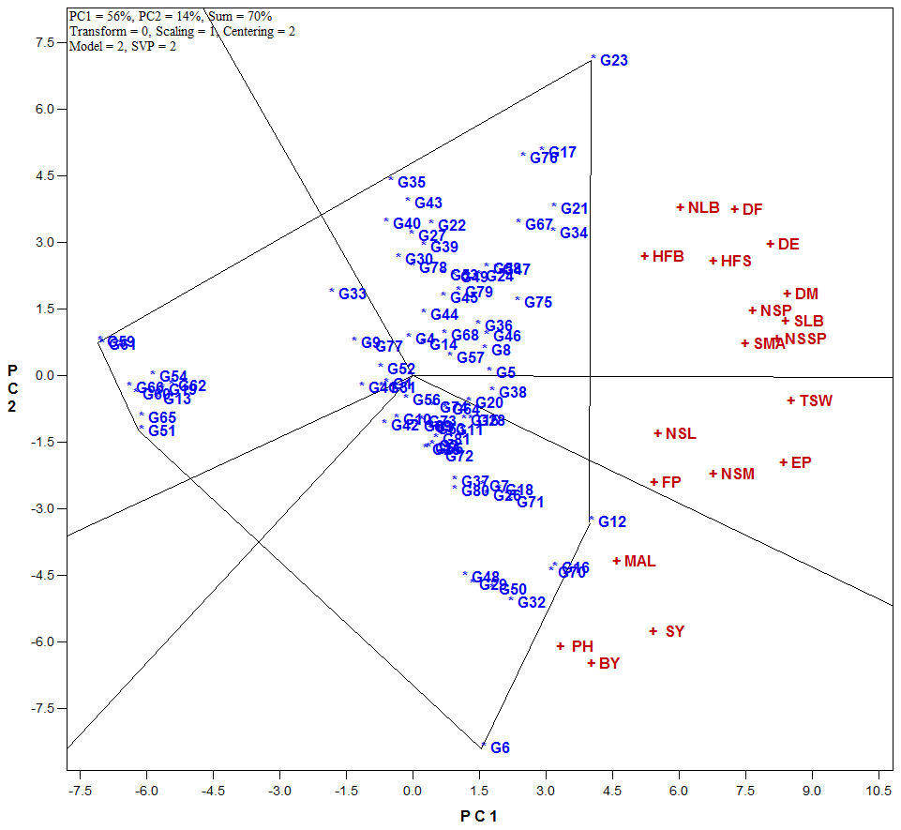
Figure 1. Polygon-view option of biplot representing the “which-won-where pattern of traits and genotypes.

Results and Conclusion: The polygon-view of the genotype by trait biplot is the best way to visualize the structure of relations between genotypes and traits. Figure 1 represents the mentioned biplot generated from data on morphologic traits of Lepidium sativum genotypes. The following information can be seen from this figure: the vertex genotypes for the first year are G23, G59, G61, G51, G6 and G12, and the trait fell into the sectors of G23 and G12 in the first year. Therefore, genotype G12 had the highest values of plant height (PH), main axis length (MAL), seed yield (SY) and biological yield (BY) traits; and genotype G23 had the highest values of the other remained traits (Figure 1). Therefore, there are two vertex genotypes in Figure 1 which were favorable for some traits but the rest of them (four vertex genotypes) were not favorable for any garden cress traits.
An analysis of variance confirmed results of the genotype by trait biplot that there was significant genotype × trait interactions in most of measured traits. This means that Lepidium sativum genotypes may produce high seed yield only in some genotypes and the traits are not stable across genotypes. In the testing of different interactions for significance, one of the common practices is the tendency to apply multiple mean comparisons while these comparisons do not give extra information about the nature of interactions such as positive or negative interactions. Therefore, the genotype by trait biplot procedure, gives the same information as analysis of variance as well as additional information of multiple mean comparisons (Dehghani et al., 2008).
However, genotypes G12, G20, G23, G32 and G53 as the vertex genotypes were the most favorable genotypes in the most important studied traits of Lepidium sativum in each two years. On the other hand, genotype by trait biplot explained most of the variation (70 %) due to Lepidium sativum genotypes main effects plus genotype × trait interaction effects. It can be said that almost all information contained ANOVA and multiple comparisons of genotype means is graphically displayed in a genotype by trait biplot. Ma et al. (2004) in Triticum aestivum, and Dehghani et al. (2008) in Brassica napus, also reported similar findings in the studying of effects of genotype, environment, treatment, trait and their interactions. Finally, the biplot shows a complete picture of the interrelationships among genotypes and traits (Yan and Rajcan, 2002). For above mentioned reasons we prefer the use of genotype by trait biplot model for analyzing in Lepidium sativum dataset. Similar reports demonstrated that the genotype by trait biplots were an excellent tool for visualizing genotype × trait dataset and revealing the interrelationships among different traits (Rubio et al., 2004).
Keywords: biplot analysis, germplasm collection, traits association.
References
Dehghani, H., Omidi, H., Sabaghnia, N., 2008. Graphic analysis of trait relations of rapeseed using the biplot method. Agron. J. 100, 1443–1449.
Ma, B.L., Yan, W., Dwyer, L.M, Fregeau-Reid, J., Voldeng H.D., Dion Y., Nass H., 2004. Graphic analysis of genotype, environment, nitrogen fertilizer, and their interactions on spring wheat yield. Agron. J. 96: 169–180.
Rubio, J., Cubero J.I., Martin L.M., Suso M.J., Flores F., 2004. Biplot analysis of trait relations of white lupin in Spain. Euphytica 135, 217–224.
Yan, W., Rajcan I., 2002. Biplot evaluation of test sites and trait relations of soybean in Ontario. Crop Sci, 42: 11–20.

