Evaluation of foliar application of salicylic acid on quantity and quality of Cynara scolymus as a medicinal source

Naser Sabaghnia ^{1*}, Mohsen Janmohammadi ¹
1-Depatment of Plant Production and Genetics, University of Maragheh, Maragheh, Iran
^{sabaghnia@yahoo.com}
Statement of Problem: Among the herbal medicines the Cynara scolymus used in treatment of hepatic/biliar diseases, gastrointestinal disorders. It is source of Ca, K, Mg, Na, P, Cu, Fe, Mn, Se, and Zn. Trait profiles under salicylic acid application and trait relations are influenced by genotypic as well as environmental factors.
Research Purpose: A little is known about trait relations of Cynara scolymus and the objectives of this investigation were to evaluate its performance under salicylic acid application, reveal the interrelationship among traits, and compare among genotypes on the basis of multiple traits, which can be candidate for next improvement of Cynara scolymus.
Research Method: The experimental trial was conducted in randomized complete block design using factorial arrangement with three replicates. The first factor was consisting on three planting dates spaced at about 19 April, 5 and 20 May while the second factor was consisting on three salicylic acid concentrations (0, 700 and 1400 µM). Salicylic acid (SA) was dissolved in absolute ethanol then added drop-wise to water (ethanol/water: 1/1000, v/v). Salicylic acid was applied on the foliage of plants with a hand sprayer on 45 days’ plants at the five-leaf stage). A control group of plants was grown sprayed with deionized water. Chlorophyll content was measured on ten leaves of a plant at each plot, using a portable chlorophyll meter. The relative water content (RWC) was determined. Leaf area, leaf number per plant, plant fresh forage yield, dry matter and forage quality were recorded. Dry matter yield was determined through the weighting the dried plants at 70°C for 24 h. Primary statistical analyses were performed using the Anderson-Darling normality test and Levene homogeneity test. Homogeneity of residual variance was determined by Bartlett’s homogeneity test. To explore treatment by trait interaction variability, the SREG model was used presented by Yan and Rajcan (2002). To visualize correlations between traits, a vector view biplot was made. These graphic analyses were done using the GGEbiplot software.
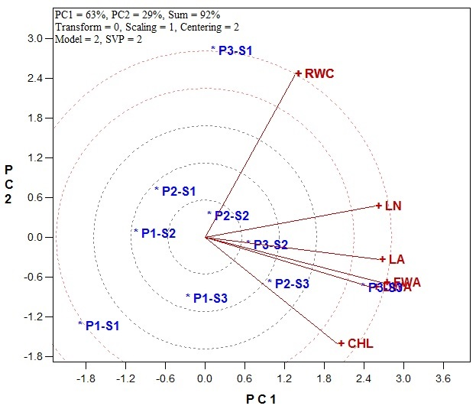 | 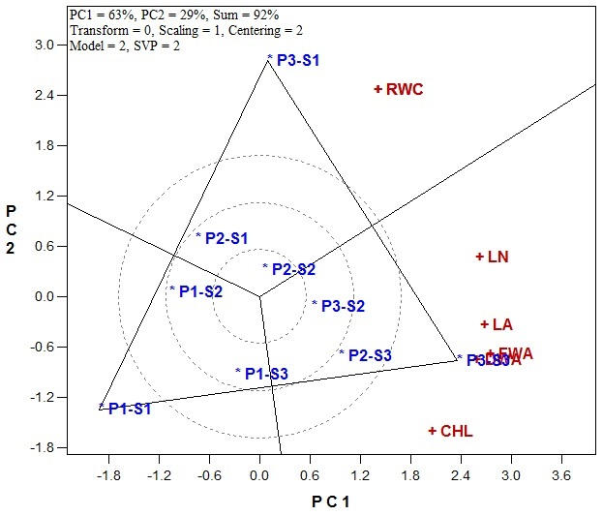
Figure 1. Vector-view option of biplot representing the relationships pattern of traits. | Figure 2. Polygon-view option of biplot representing the “which-won-where pattern.

Results and Conclusion:
The treatment by trait biplot explained 63 and 29% of the total variation of the standardized data, respectively (Figure 1). This high percentage reflects the ability of biplot model to modeling the relationships among the measured traits of Cynara scolymus. The fundamental structures among the traits should be captured by the biplots. In the treatment by trait biplot, a vector is drawn from the biplot origin to each of the traits to facilitate visualization of the relationships among traits; and the correlation coefficient between any two traits is approximated by the cosine of the angle between their vectors. In other word, provided that the biplot explained a sufficient amount (≥50%) of the total variation, two traits are positively correlated if the angle between their vectors is <90°, negatively correlated if the angle is >90°, independent if the angle is 90° (Rubio et al., 2004). Also, traits with longer vectors are more responsive to the genotypes; traits with shorter vectors are less responsive to the treatment genotypes; and those located at the biplot origin are not responsive at all. The most prominent relations revealed by vector-view biplot (Figure 1) are: a positive association between FWA and DWA and in lower step among LA, LN FWA and DWA as indicated by the acute angles (Figure 1). There were near zero coloration between RWC and Chl as indicated by the 90° angle while we did not found any negative association among traits sue to the large obtuse angles between vectors of the traits.
The polygon-view of the treatment by trait biplot is the best way to visualize the structure of relations between treatments and traits. Figure 2 shows the mentioned biplot generated from data on traits of Cynara scolymus. The following information can be seen from this figure: the vertex treatments are P1-S3, P3-S1 and P3-S3, and most traits fell into the sector of P3-S3. Therefore, treatment P3-S3 had the highest values of all traits except relative water content (RWC) which was felt in sector of treatment P3-S1 (Figure 1). Therefore, there are two vertex treatments in Figure 1 which were favorable for some traits but the rest of them (one vertex treatment as P1-S3) were not favorable for any garden cress traits. It seems that application of salicylic acid in high magnitudes with delay planting can increase the performance of most traits in Cynara scolymus.
Our results showed that spraying salicylic acid on the Cynara scolymus plants enhanced plant growth especially in high concentration while sowing date influences its growth, development and yield depending on salicylic acid concentrations due to observing the interaction effects between two factors. Although, the meaningful difference was not observed between second and third sowing dates in analysis of variance, but the treatment by trait biplot identified the P3-S3 (sowing 20 May and spaying salicylic acid at concentration 1400 µM) treatment combination as the best. It was shown that foliar application of acid salicylic on plants under normal growth conditions provided protection against stresses. Besides, the obvious visual symptom, this conclusion was confirmed by chlorophyll fluorescence parameters and electrolyte leakage measurements from the leaves (Hosseinzadeh et al. 2013).
Keywords: SREG analysis, sowing date collection, traits coloration.
References
Rubio, J., Cubero J.I., Martin L.M., Suso M.J., Flores F., 2004. Biplot analysis of trait relations of white lupin in Spain. Euphytica 135, 217–224.
Yan, W., Rajcan I., 2002. Biplot evaluation of test sites and trait relations of soybean in Ontario. Crop Science, 42: 11–20.
Hosseinzadeh, M., Shekari, F., Janmohammadi, M., Sabaghnia, N. 2013. Effect of sowing date and foliar application of salicylic acid on forage yields and quality of globe artichoke (Cynara scolymus L. Annales Universitatis Mariae Curie-Skłodowska Lublin – Polonia 68(2), 50-59.

