Genetic variation of medicinal herb Spinacia oleraceae using biplot analysis

Naser Sabaghnia ^{1*}, Mohsen Janmohammadi ¹
1-Depatment of Plant Production and Genetics, University of Maragheh, Maragheh, Iran
^{sabaghnia@yahoo.com}
Statement of Problem: Spinacia oleracea is an edible plant from the Amaranthaceae is native to central and Southwestern Asia and a rich source of various vitamins (A, C, E, K, B6 and B2), magnesium, manganese, folate, betaine, iron, calcium, potassium, folic acid, copper, protein, phosphorous, zinc, niacin, selenium and omega-3 fatty acids. Spinacia oleracea packed with a number of anti-oxidants like polyphenols, flavonoids and carotinoids which are shown to possess anti-inflammatory effects, antimutagenic potential, anti-neoplastic effects as well as chemo-preventive activates.
Research Purpose: Various activities of Spinacia oleracea have been reported and various secondary have been reported from this plant while a little is known about trait relations of Spinacia oleracea and the objectives of this research were to evaluate the performance of some genotypes, reveal the interrelationship among traits, and compare among genotypes on the basis of multiple traits, which can be candidate for future breeding of Spinacia oleracea.
Research Method: Sixteen Spinacia oleracea germplasm were evaluated in a randomized complete block design with four replication times. Each plot contained six 3 m long rows with 25 cm between rows and plot size was 4.5 m². Control by hand weeding was carried out twice when the weed density was high, in the pre-flowering and post-flowering stages. Several quantitative traits consist on leaf length (LL), leaf width (LW), petiole length (PL), petiole diameter (PD), leaf area (LA), leaf numbers in flowering (LN), days to flowering (DF), female plants percent (FP), fresh yield (FY) and dry yield (DY) were measured. The datasets were first tested for normality by Anderson and Darling normality test. The genotype × trait biplot model (Yan and Frégeau-Reid, 2018) was used to show the two-way pattern of Spinacia oleracea landraces’ traits in a biplot model. All biplots presented in this study were generated using the software GGEbiplot package. Up-to-date information on GGE biplot and new version of GGEbiplot package are available at http://www.ggebiplot.com.
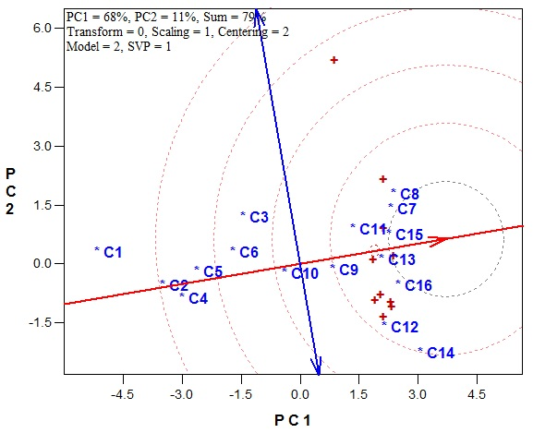 | 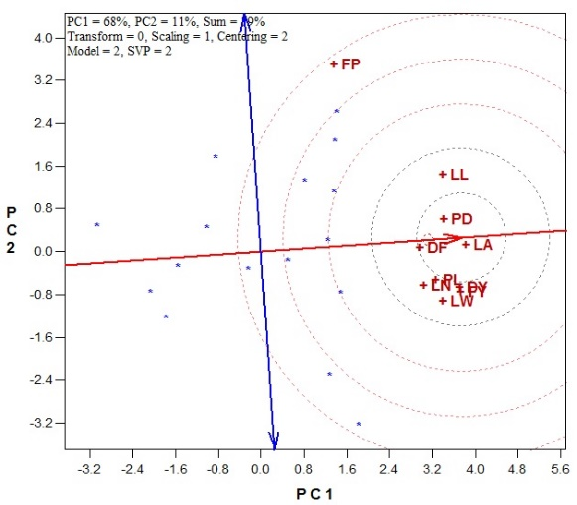
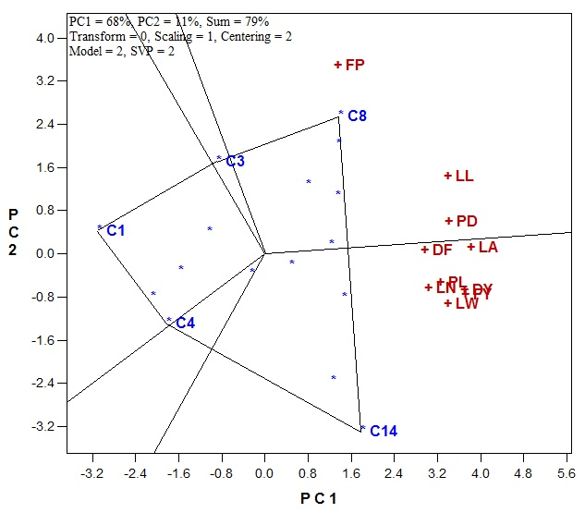 | 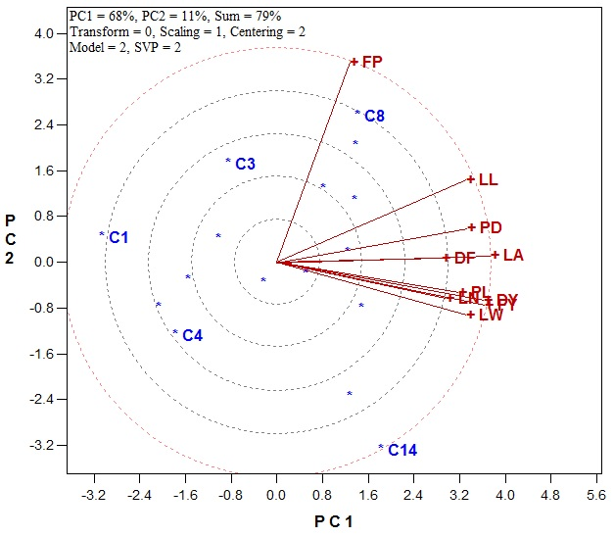
Figure 1. The genotype × trait biplot model (up-left) ideal genotype, (up-right) ideal trait, (down-left) polygon-view, and (down-right) tester view.

Results and Conclusion: The genotype × trait biplot explained 68 and 11% of the total variation. This relatively moderate percentage reflects the complexity of the relationships among the measured traits. The mean effects of the measured across genotypes were examined by defining an average tester coordinate axis and an average or virtual genotype is indicated by a circle and shows the positive end of the axis. Ideal genotype is it that should have large PC1 scores (high traits’ means) and small (absolute) PC2 scores (low variability). Genotypes with above average means was selected, whereas the rest were discarded, thus genotype C7, C8, C11, C13, C15 and C16 were the most favorable genotypes regarding all of the measured traits due to its low distance from horizontal axis (Figure 1).
According to ideal tester (trait), leaf area was the most representativeness one and had the most discriminating ability for detection differences among genotypes. Ranking of the best traits based on the ideal tester was PD> DF=PL=DY=FY> LN=LW > LL > FP (Figure 1). The polygon view of the GT biplot helps identify genotypes with the highest values for one or more traits and provides the best way for visualizing the interaction patterns between genotypes and traits and to effectively interpret a biplot. The biplot Figure 1, as polygon view, presents data of 16 Spinacia oleracea landraces in ten traits and the following information can be understood: the vertex landraces or genotypes in this investigation are C1, C3, C4, C8 and C14. These landraces are the best or the poorest landraces in some or all of the traits since they had the longest distance from the origin of biplot (Ebadi-Segheloo et al., 2014).
Therefore, it seems that C14 had the highest values for traits leaf width (LW), petiole length (PL), leaf area (LA), leaf numbers in flowering (LN), days to flowering (DF), fresh yield (FY) and dry yield (DY). This genotype (C14) and the other genotypes of this sector had good amounts of above mentioned traits. The vertex landrace C8 and its related genotypes which fall in its sector were good for petiole diameter (PD), leaf length (LL) and female plants percent (FP). Therefore, there are two vertex genotypes in Figure 1 which were favorable for some traits but the rest of them (four vertex genotypes) were not favorable for any Spinacia oleracea traits. Finally, the biplot shows a complete picture of the interrelationships among genotypes and traits (Sabaghnia et al., 2016).
The petiole diameter (PD), days to flowering (DF) and leaf area (LA) were positively associated with each other while petiole diameter (PD), days to flowering (DF), and leaf area (LA) were positively correlated with each other (Figure 1). The female plants percent (FP) did not show any positive or negative association with the petiole diameter (PD), days to flowering (DF) and leaf area (LA). For above mentioned reasons we prefer the use of genotype by trait biplot model for analyzing in Spinacia oleracea dataset. Similar reports demonstrated that the genotype by trait biplots were an excellent tool for representing genotype × trait dataset (Yan and Frégeau-Reid, 2018).
Keywords: Germplasm collection, site-regression analysis, traits association.
References
Ebadi-Segheloo, A., Asadi-Gharneh, H., Mohebodini, M., Janmohammadi, M., Nouraein, M., Sabaghnia, N. 2014. The use of some morphological traits for the assessment of genetic diversity in spinach (Spinacia oleracea L.) landraces. Plant Breeding and Seed Science, 69, 69-80.
Sabaghnia, N., Mohebodini, M., Janmohammadi, M. 2016. Biplot analysis of trait relations of spinach (Spinacia oleracea L.) landraces. Genetika, 48(2), 675-690.
Yan, W., and Frégeau-Reid, J. 2018. Genotype by yield*trait (GYT) biplot: a novel approach for genotype selection based on multiple traits. Scientific reports, 8(1), 1-10.

