**Green synthesis of Ag nanoparticles using *Cyperus rotundus* aqueous extract**

Esmaeil Arghiyani*, Behnam Mahdavi, Musa Al-Reza Jafari, Sajjad Kashki

*\* E-mail :* [*Esmaeil.arghiyani@gmail.com*](mailto:Esmaeil.arghiyani@gmail.com)

**‌ Statement of Problem:** Silver nano­particles are considering famous nanoparticles because of their antibiotic activity against viruses, bacteria, fungi, cancers and parasites. *Cyperus rotundus* Linn has wide range of medicinal and pharmacological applications. 3,4-Dihydropyrimidine-2-(1*H*)-ones(DHPMs) have pharmacological properties and can be prepared by the Biginelli reaction. Synthesis of silver nanoparticles and DHPMs is difficult.

**Research Purpose:** Due to the medical and pharmaceutical applications of metallic silver nanoparticles and 3,4-dihydropyrimidin-2(1*H*)-(thi)one derivatives, in this study we are looking for the green synthesis of these products.

**Research Method:** The aqueous extract of *C. rotundus* was mixed with a solution of AgNO3 and stirred at 70 oC for 15 minutes. During the reaction time, the dark brown of AgNPs was formed. AgNPs were used as the catalyst in Biginelli reaction. benzaldehyde, urea, ethyl acetoacetate and catalyst were refluxed for 20 minutes at 100 °C.

**Results and Conclusion:**The XRD peaks at 38.27, 44.46, 64.72 and 77.65 correspond to the (111), (200), (220) and (311) plane(Figure A). The presence of the bands at 3100 -3300(N-H), 1720(C=O) and 1100-1200(C-O) in the FT-IR spectrum confirm the synthesis of 3,4-dihydropyrimidin-2(1*H*)- one(Figure B).

 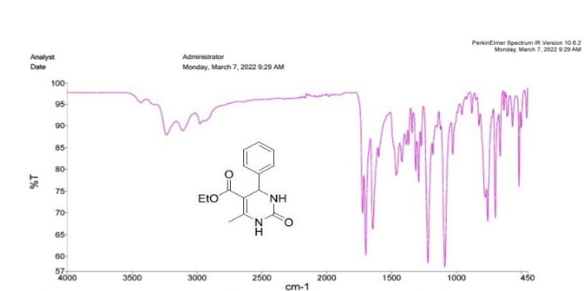

Figue A Figure B

**Keywords: Ag nanoparticles**, ***Cyperus rotundus*, Biginelli reaction.**